Hargreaves Lansdown

Value Investing Analysis
March 2021

By Lars Christian Haugen & Roshni Patel

www.hpvalueinvesting.com

Want to invest with us? Go to etoro.com and copy our portfolio.

Want to see the video version? Click below:

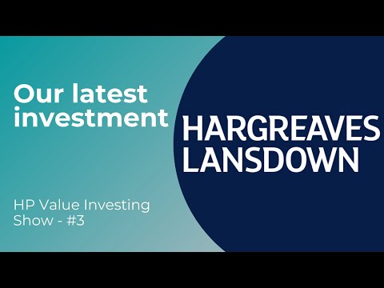
About the Company 3
Historical P/E Ratio 3
Share Price History 4
Investment Thesis 4
Business Tenets 5
Consistency 5
Competitive Advantages 5
Industry Analysis and Future Growth 6
The Savings Gap 7
Growing Younger Demographic 8
Management/CEO Analysis 8
Financial Tenets 9
Return on Equity 9
Free Cash Flow 9
Profit Margins 10
Valuation 11
Risks 11
Conclusion 12

About the Company
Hargreaves Lansdown (HL) is an online investing platform where retail investors can buy/sell shares and funds. They also offer investment research, cash savings accounts, retirement accounts etc.

They make money in several different ways, among others:
- charging people for buying/selling shares.
- charging people for holding funds.
- earning interest on client money.

Historical P/E Ratio
Before we move into the analysis, we think it’s worth pointing out that HL’s PE ratio is almost at a historical low. Although we can’t draw any major conclusion from just one chart, it suggests that now might be a good time to invest in HL because it’s trading at a low valuation.

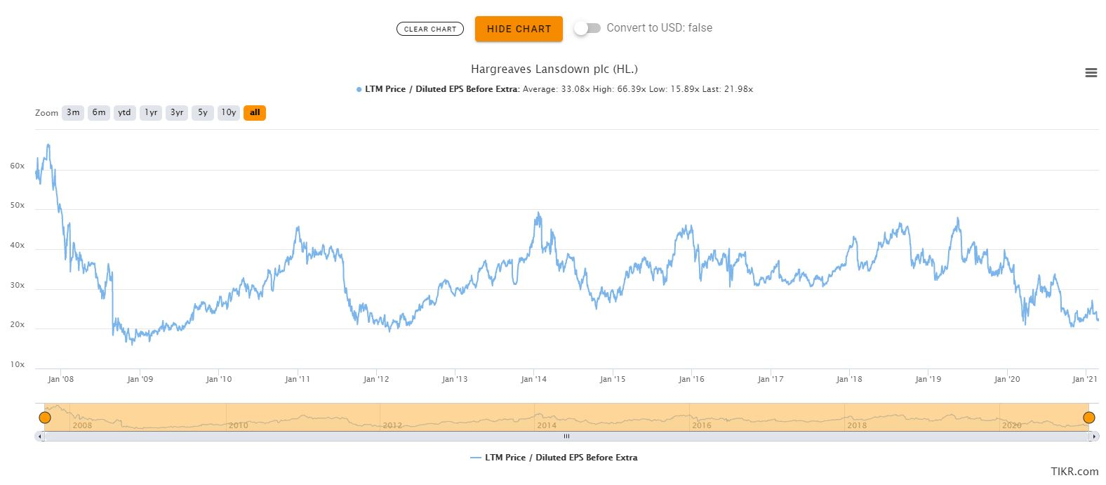

Share Price History
We can see that the share price is almost back to where it was 3-3.5 years ago. After the Woodford incident in mid-2019 (which we cover below), the share price has come down, which presents us with a good entry point.

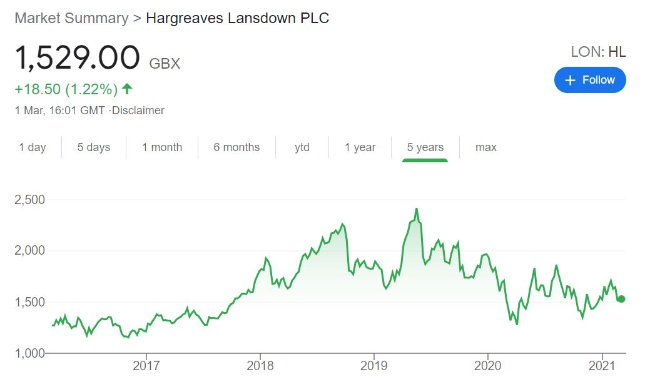

Investment Thesis
HL is the market leader in the retail investment platform market in the UK. They have a strong brand, excellent financials, operate in an industry with potential for further growth, and trade at a favorable valuation.

We bought shares at around £15 in February 2021.

To see, and copy, our portfolio on eToro, please click here.

Business Tenets

Consistency
Hargreaves Lansdown has a consistent operating history, which we like because it makes it easier to value the company. Net income has consistently been growing over the last 15 years, and return on equity has been consistently high. Although the past is not a predictor of the future, the company’s strong track record suggests that there is a good likelihood that it can continue to grow in a stable manner in the future.

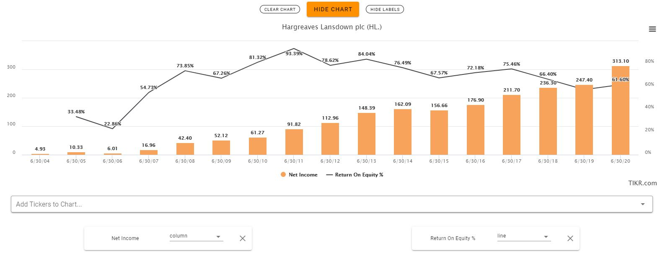
Source: tikr.com

Competitive Advantages
HL has a strong brand name, and it is the market leader in the direct to consumer investment platform market in the UK, with a market share of around 40%.

According to an article by Platforum - which is a consultancy that advises on the direct to consumer investment space - the biggest players in the space are able to offer services that are “demonstrably stronger than the rest” - i.e. scale matters.

HL is the largest player, followed by Interactive Investor and Fidelity Personal Investing.

Platforum says that scale is important because it enables companies to invest in its technology, and customer service, which are two important aspects to staying competitive.

Even big banks like Barclays are struggling to develop technology (Barclays Smart Investor) that can compete with HL and the like.

This digitalisation allows HL to cater to the growing younger market through their phone app, and through simple informational video and reading content on the topic of financial management. We think this makes HL more accessible and attractive to people who are new to investing, but want to learn more.

We therefore believe that HL is in a strong competitive position, due to its brand name, easy-to-understand learning content, and scale - which positions it well for the long term.

Industry Analysis and Future Growth
There is scope for HL to grow in the future.

They currently have £120bn of assets on their platform (assets under administration), but they estimate that there is an addressable market of £2.4 trillion, i.e. 20 times their current assets under administration (see image below).

£1 trillion is in private wealth, the bulk of which is held through independent financial advisers.
HL believes these clients don’t receive ongoing support, and also that they want to manage their investments in one place, with a trusted company that makes things easy.

HL has helped many clients go through this consolidation process.

The remaining £1.4 trillion is held in cash, despite the low interest rate environment. That cash might start being invested in shares and funds, given that the holders aren’t getting any return on it these days.

But even if it is held in cash, HL provides a service for managing cash savings, which offers a better return than big banks. This service gives clients access to 12 different banks that they can put their money in, all through the HL platform.

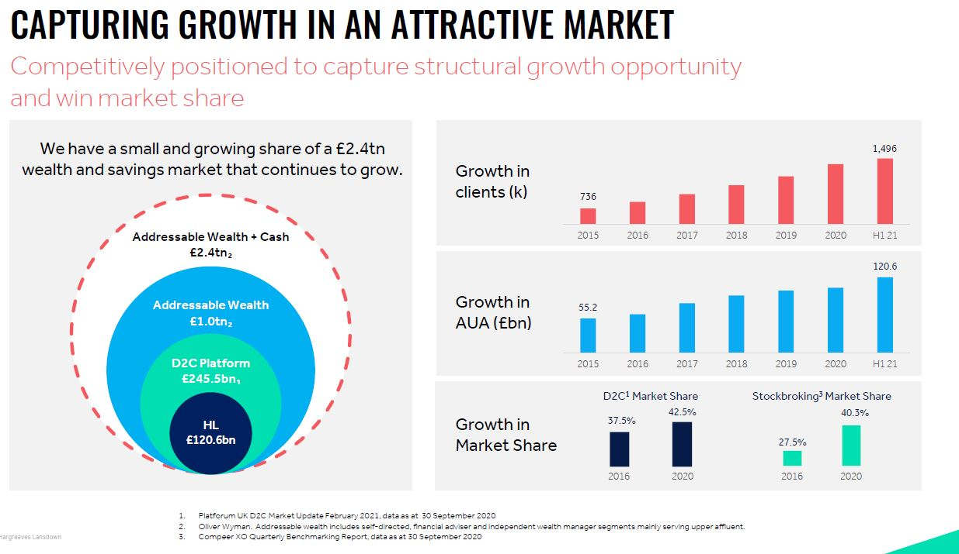
Source: Hargreaves Lansdown interim results 2021 presentation

The image also shows how clients and assets under administration have grown steadily over the last five years, and how their market share has grown as well.

The Savings Gap
There is a savings gap in the UK.

The gap between retirement expectations, and the cost of funding such expectations, is estimated at £314 billion, according to HL’s 2020 annual report.

The level of funding necessary to provide retirement income is increasing, driven by longer life expectancies, less generous company pensions and people’s ambitious retirement expectations (people want good retirements).

The burden of responsibility for retirement is shifting from the government and companies, to the individual.

This gap cannot be closed without individuals taking ownership for self-provision and without the use of long-term investments alongside cash savings.

This is an opportunity for HL.

Growing Younger Demographic
From our personal observation, younger retail investors now want to participate in the market. Our friends are becoming more interested in investments, and it’s becoming easier to participate, due to platforms like HL.

In these uncertain pandemic times, and low interest rate environment, more young people are realising that they need to manage their own finances.

This demographic shift is significant because (1) it means that HL gets more clients, and (2) since these clients are younger, they might be with the company for the next 30-40 years, providing HL with recurring revenue for decades to come.

Management/CEO Analysis
HL is open about what the CEO and CFO are paid, which shows that the company is candid. This is a good sign. We want a company to be candid with shareholders because it means we can trust them.

Another point that is worth mentioning, which gave us insight into the integrity of the management, is the Neil Woodford incident. Neil Woodford is a well-known investor in the UK, and he used to be highly respected. However, in 2019 his fund was closed. Leading up to that year he had made some unusual investments in small and illiquid stocks, which led to poor performance. Consequently, investors started pulling their money out of the fund, and as a result the fund eventually closed down. A lot of retail investors lost money in that fund.

How is HL connected?

They had recommended the Woodford fund on their list of top 50 funds. Woodford had underperformed for 2-3 years, but they thought he would bounce back (as he had done before). HL is therefore somewhat responsible for investors losing money because they could have done better due diligence on the fund, however very few people could have predicted that the UK’s most famous fund manager would have his fund closed like that.

Despite their limited responsibility, in the 2019 annual report (p.18) the CEO apologised for the incident, and said that he and the CFO would not take a bonus that year. They also waived the platform management fee on direct holdings in the Woodford fund.

We mention these points because we think the management’s actions with regards to the Woodford incident show that they have integrity, and that they admit their mistakes. These are important attributes for managers to have.

And the last point we want to mention in our management analysis is that HL removed its platform exit fees (people having to pay when leaving the platform) in September 2019, which seems to be something not a lot of other platforms are doing. This suggests that HL are “trailblazers”, and that they are working to make the industry fairer for clients, which we like. And in the end, we believe that such actions will translate into revenues in the future, because people want to do business with a company that treats them fairly.

Financial Tenets

Return on Equity
ROE has been consistently high over the last 15 years, and the lowest reading was 23% in 2006, which is still very high. After that, ROE ranged mostly between 60%-80%. These are excellent ROE figures because they are on average much higher than most businesses.

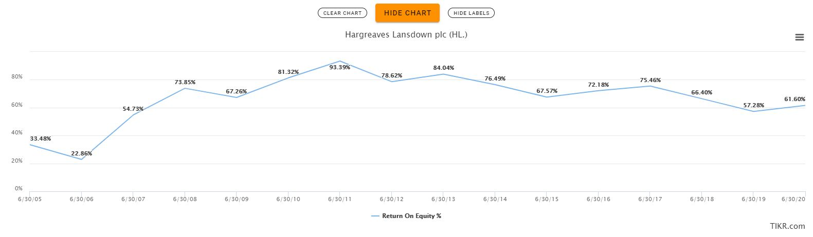
Source: tikr.com

Free Cash Flow
The company is generating increasing amounts of free cash flow and the capex is negligible compared to the cash flow from operations (this is good because it means the capex will not eat into the FCF as the operations grow). This is great because we like companies that consistently generate increasing levels of free cash for its shareholders.

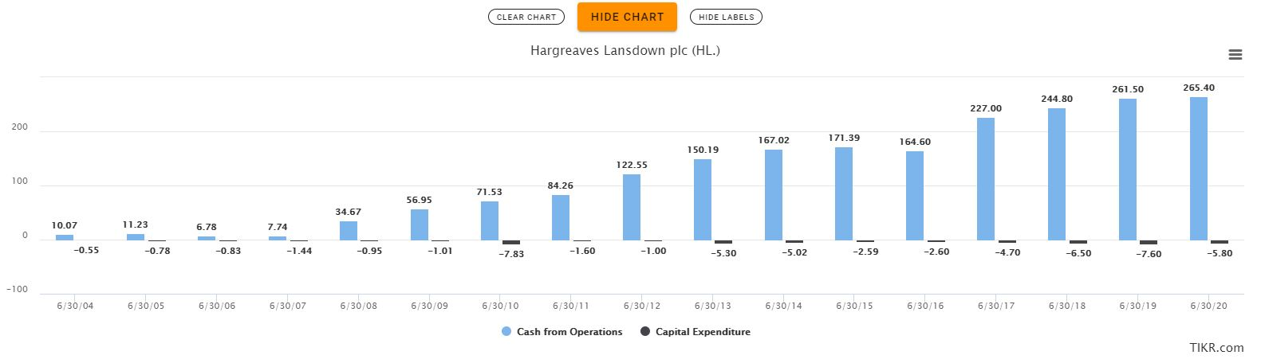
Source: tikr.com

Profit Margins
HL has excellent profit margins. The gross profit margin has been very consistent over the years, with the lowest number being 67% in 2014. The operating margin and net margin steadily grew from good levels, to excellent levels, in 2013, where they have stayed since. The net margin over the last five years was consistently above 50%, which is extremely good. There has not been a single year with a negative net margin in the last 15 years, which adds to the company’s investment appeal, because they are consistently making money for shareholders.
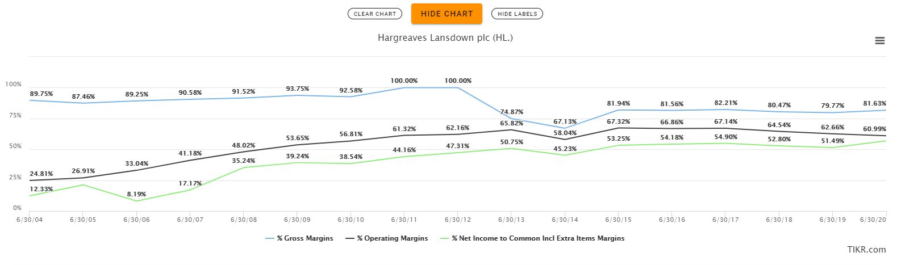
Source: tikr.com

Valuation

We used a DCF analysis to look at two different valuation scenarios. For the first scenario we estimated that the free cash flow would grow 10% per year, over the next 10 years. And for the second scenario we estimated it would grow 10% per year for the next 20 years.

We thought these estimates were reasonable given that the free cash flow has compounded at 24% annually over the last 15 years.

We then used a terminal value growth rate of 2% and a discount rate of 10%.

Given these assumptions, our fair value estimates were in the range of £13-£18 per share. We therefore thought that the share price of £15 at the time offered a good opportunity to buy, which we did.

Risks
One of the main risks that we have identified with HL is that there is a lot of competition in the industry. The barriers to entry are low, and the switching cost for a client to move from one platform to another is low. However, as we mentioned above, to be a major player in this space, you need money to invest in technology and customer service. The barriers to entry might be low, but the barriers to success are relatively high in our opinion.

Another risk we have identified is that if there is a market crash, retail investors might lose interest in the markets going forward. People want to invest during good times, but if the stock market goes through a violent crash (a la 1929), people might be put off investing for many years to come. This might lead to a period of low secular growth, or even decline, for HL.

The last risk factor we want to highlight is that our estimates of free cash flow growth might be too high. We assumed that FCF would grow 10% per year, for the next 10 and 20 years. If that is too optimistic of an assumption, our valuation will be overstated. We did not buy the shares at a large discount to our intrinsic value estimates, and therefore if our growth estimates are wrong, we will likely have overpaid for the stock.

Conclusion
Hargreaves Lansdown is a quality company that is trading at a reasonable price. The company has competitive advantages, in the form of (1) a strong brand name, and (2) a size advantage that allows it to invest in technology and customer services.

Their financials are excellent, and they are the market leader in a growing industry. We estimate that the fair value per share is around £13-£18, and we purchased shares at around £15 in February 2021.

We plan on holding the shares for the long term.

Thank you for reading our report, and we hope you enjoyed it.

Lars Christian Haugen & Roshni Patel

To find more of our content, please visit www.hpvalueinvesting.com/blog

